Ali Fina
Bio 100
Professor Lloyd

Multiple Genes Linked To Differences In Cystic Fibrosis Identified

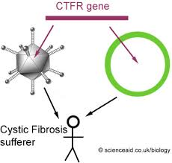

This article discusses research done by scientists to try to figure out why people with the same CFTR mutations can have completely different courses of the disease. They were looking to find other possible contributors to the different aspects of the disease. They discovered something called meconium ileus, which could be a possible answer. Meconium ileus is a severe intestinal obstruction that is present in 15 percent of births with CF.
The scientists studied around 4,000 genomes of CF patients. They tried to identify other CF genes that would cause sickness in patients in certain organs. If they can find out which genes are making people sick, they can come up with individual treatments for CF patients.
The scientists used scientific pathways, such as research and discovery, benefits and outcome, and community analysis and feedback. They researched the CF genes and discovered which were causing problems. The community analysis and feedback were positive and they want to support the future research. The benefits would be personalized treatments for CF patients.

http://www.medicalnewstoday.com/releases/243678.php

