Ali Fina
Bio 100
Lucy Lloyd

A Cystic Fibrosis Treatment is Called “Game Changing”
By Reuters
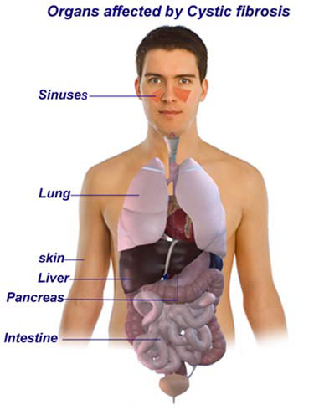
The article discusses how a combination of a cystic fibrosis drug and an experimental treatment of the disease led to significantly improved breathing ability. The drug they developed will help only about 4 percent of patients with a specific gene mutation. This drug is the first approved drug that treats the underlying cause of the disease other than the symptoms.
The study looked at 37 patients who went through 56 days of treatment with the drug and vx-809. The results of the study showed a statistically significant lung infection improvement. The drug worked better than the scientists had expected it to.
This relates directly to my topic of cystic fibrosis. The study was done specifically on people with cystic fibrosis. This study is one of many that is going to help in the advancement of treatment for patients with cystic fibrosis.
The scientific pathways used in this article were exploration and discovery, testing ideas, community analysis and feedback, and benefits and outcomes. The exploration and discovery was finding out what they needed to do to make the drug. They tested their ideas by testing the drugs on cystic fibrosis patients. Community analysis and feedback came from people with cystic fibrosis who were very happy with the outcome. The benefits and outcome were that they are a step closer to better treating cystic fibrosis.
This drug could help people with cystic fibrosis live a better and healthier life. I don’t have cystic fibrosis, but this drug could eventually help someone that I know with the disease.

